FINAL PROJECT REPORT

***Three players Prisoner's Dilemma (iterated version)***

|  |  |  |  |
| --- | --- | --- | --- |
| **Project Information** | | | |
| **Project Title** | *Three player Prisoner’s Dilemma ( iterated version )* | | |
| **Project Type** | Graduate Semester project | | |
| **Project Period** | Fall 2014 semester | | |
| **Start Date** | 9/9/2014 | **End Date** | 12/02/2014 |
| **Lead Institution** | New Mexico State University | | |
| **Department** | Computer Science | | |
| **Project Director** | Dr. William Yeoh | | |
| **Project Team** | Samuel Djiani & Bright Kpe | | |

**Introduction**

Prisoner’s Dilemma is apparent ideology of how the use of uncoordinated selfish actions traps groups of people into non-cooperative situations with immense consequences as compared to cooperative actions among them to moderate or maximize or minimize their outcomes. Naturally humans have self-interest especially when it involves survival, and identifying the conditions under which the dilemma disappear in order for social optimality to reach by uncoordinated individual actions has been a major theme of diverse research.

The Prisoner dilemma can be used as a model for many real world situations involving cooperative behavior: social sciences such as economics, politics, and sociology; biological sciences such as ethology and evolutionary biology; and many others domains. This widely applicability of the prisoner dilemma gives the games its substantial importance.

**MOTIVATION**

The **Enron scandal**, revealed in October 2001, eventually led to the bankruptcy of the Enron Corporation, an American energy company based in Houston, Texas, and the de facto dissolution of Arthur Andersen, which was one of the five largest audit and accountancy partnerships in the word. Since the Enron scandal, Americans are more closely scrutinizing the prosecution and sentencing of white-collar criminals. The Bureau has defined white-collar crime as “those illegal acts which are characterized by deceit, concealment, or violation of trust and which are not dependent upon the application or threat of physical force or violence.

From the FBI statistics, the white-collar crime rate is on the increase but very difficult to prosecute these caliber of intellectuals which can manipulate the evidence with the help of their prosecutors and almost impossible to employ forensic evidence in some of the cases.

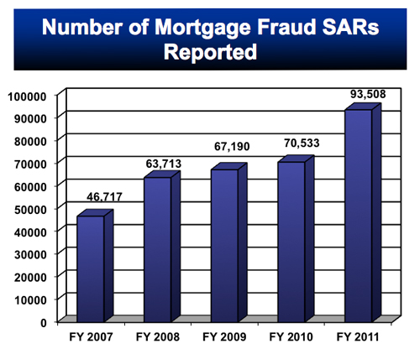

*From FBI website*

**Problem Description**

**Three players Prisoner's Dilemma**

Consider a game of Prisoner’s Dilemma. Only instead of two criminals, the FBI must interrogate three criminals. What would the payoff matrix look like for this game? What would be the rules? What would be the Dominate Strategy for each player?

Suppose the payoff matrix for a three-player game of Prisoner’s Dilemma is 3-D, then it would look like a cube, made up of 8 smaller cubes. Each cube represents a different outcome. Listed below are the outcomes, C for to confess and NC for not to confess.

(Player 1, Player 2, Player 3)

(C, C, C) (C, NC, C), (C, C, NC) (C, NC, NC)

(NC, C, C) (NC, NC, C) (NC, C, NC) (NC, NC, NC)

Suppose there are some rules. If all three players confess, each player gets 6 year in jail. If all three players refuse to confess, each player gets 1 months. If only one player confesses, he/she walks, and the other two gets 6 years each. Finally, if two players confess, they get 3 years each, and the third player gets 10 years. Listed below are the outcomes with appropriate jail times for each player.

(Player 1, Player 2, Player 3) = (#, #, # )

(C, C, C) = (6, 6, 6) (C, NC, C) = (3, 10, 3)

(C, C, NC) = (3, 3, 10) (C, NC, NC) = (0, 6, 6)

(NC, C, C) = (10, 3, 3) (NC, NC, C) = (6, 6, 0)

(NC, C, NC) = (6, 0, 6) (NC, NC, NC) = (1, 1, 1)

Let’s analysis the outcomes from Player 1’s perspective: if Player 2 and Player 3 confesses, Player 1 should confess, 10>6; if Player 2 confesses and Player 3 refuses to confess, Player 1 should confess, 10>3; if Player 2 refuses to confess and Player 3 confesses, Player 1 should confess, 10>6; if Player 2 and Player 3 refuse to confess, Player 1 should confess, 1>0. Thus, to confess is a Dominate Strategy for Player 1, this process works the same way for Player 2 and Player 3.

**Dominate Strategy:**

Player 1: C – Player 2: C → Player 3: C

Player 1: C – Player 2: NC → Player 3: C

Player 1: NC – Player 2: C → Player 3: C

Player 1: NC – Player 2: NC → Player 3: C

**Player 3’s Dominate Strategy = C**

Player 1: C – Player 3: C → Player 2: C

Player 1: C – Player 3: NC → Player 2: C

Player 1: NC – Player 3: C → Player 2: C

Player 1: NC – Player 3: NC → Player 2: C

**Player 2’s Dominate Strategy = C**

Player 3: C – Player 2: C → Player 1: C

Player 3: C – Player 2: NC → Player 1: C

Player 3: NC – Player 2: C → Player 1: C

Player 3: NC – Player 2: NC → Player 1: C

**Player 1’s Dominate Strategy = C**

The Dominate Strategy for each player is still to confess! In Numb3rs, the FBI agent put all three criminals into the same room. Then, the mathematician presented each criminal’s risk factor. Player 1 remained indifferent, Player 2 hesitated, and Player 3 confessed almost immediately after. The actual outcome of the game is (NC, NC, C). Even though each player’s Dominate Strategy is to confess, it should be considered that some players may be more motivated to confess than others. And if timing matters, the criminal with the most to lose may confess before the others.

**Strategies implemented**

These are example strategies that might be employed in the iterated prisoner's dilemma game for this project

**Offensive** - a program using the offensive strategy simply defects on every round of every game.

**Softy**- a program using the softy strategy cooperates on every round of every game.

**Spastic**- this program cooperates or defects on a random basis.

**Democratic**- this program cooperates on the first round. On all subsequent rounds,

**Democratic** examines the history of the other player's actions, counting the total number of defections and cooperations by the other player. If the other player's defections outnumber her cooperations,

**Democratic** will defect; otherwise this strategy will cooperate.

**Eye-for-Eye-** this program cooperates on the first round, and then on every subsequent round it mimics the other player's previous move. Thus, if the other player cooperates (defects) on the *nth* round, then **Eye-for-Eye** will cooperate (defect) on the (n+1)*th* round.

**Eye-for-two-eyes:** The strategy should always cooperate unless the opponent defected on both of the previous two rounds. (Vice versa)

**Higher-order-spastic** takes a list of strategies as input. It returns a new strategy that loops through this list of strategies, using the next one in the list for each play, and then starting again at the beginning of the list when it has used all the strategies.

**Tough-Eye-for-Eye:** Tough-Eye-for-Eye should defect if either of the opponents defected on the previous round.

**Soft-Eye-for-Eye** should defect only if both opponents defected on the previous round. Play some games using these two new strategies. Describe the observed behavior of the strategies.

**Game Interface**

The interface is designed for 3 players which can be any combination of human with the computer. Each player selects his strategy without the other player knowing what his partner in crime selected. Game dependency is the key factor in this game. The simulation part is designed to project how different strategies play with each other, if the game is played over and over for number of rounds. The interface also displays the history of the game and graph of correlation between the players. It is user friendly and very intuitive and can be play without a manual.

**Hypothesis**

If iterated 3 player prisoner’s dilemma is play among the multiple defined strategies, we will notice how a strategy's performance varies sharply depending on its opponent and can predict what kind of strategies the other players might be using

The underlying idea is to keep track of how the strategy for one player correlates with the decisions of the other two players on the previous round Thus, we want to experiment and keep track of what player-1 did, correlated with what the other two players did, over the course of the histories for the three players. Imagine creating a procedure that takes three histories as arguments: call them hist-0, hist-1and hist-2.The idea is that we wish to characterize the strategy of the player responsible for hist-0. Given this is a three player game, there are three possible situations we need to keep track of: what did player-1 do on one round when the two other players both cooperated on the previous round; what did player-1 do on one round when one of the others cooperated and the other defected on the previous round; and what did player-1 do on one round when both other players defected on the previous round. Since these three situations will occur multiple times, we want to keep track of how often in each case did player-1 cooperate, and how often did she defect in response to these choices, and how often did each of these three cases occur (although that could be found by adding the number of times player-1 cooperated and defected).

**Results (50 Simulations)**

|  |  |  |  |  |
| --- | --- | --- | --- | --- |
|  | **Eye-for -eye** | **offensive** | **Softy** | **Softy is the best decision** |
| **Cooperation** | **1** | **0** | **50** |
| **Defections** | **49** | **50** | **0** |
| **Score** | **297** | **304** | **3** |

*From the simulation* ***Eye-for-eye*** *only cooperate if both players cooperate and defects if any of them defects.* ***Offensive*** *always defects and it yields the highest payoff which is the worst decision to make.*

|  |  |  |  |  |
| --- | --- | --- | --- | --- |
|  | **Eye-for -eye** | **Spasty** | **Softy** | **spasty is the worst decision** |
| **Cooperation** | **22** | **21** | **50** |
| **Defections** | **25** | **29** | **0** |
| **Score** | **309** | **316** | **129** |

***Spasty*** *acts randomly and since softy always cooperate, Eye-for-eye still defects more than cooperate because spasty defects more than cooperate. Softy still the best decision with the lowest score.*

|  |  |  |  |  |
| --- | --- | --- | --- | --- |
|  | **Eye-for-eye** | **Democratic** | **spasty** | **Eye-for-eye got the worst jail term** |
| **Cooperation** | **9** | **18** | **27** |
| **Defection** | **41** | **31** | **23** |
| **Score** | **236** | **178** | **129** |

***E****ye-for-eye got the worst or the highest jail term and spasty the lowest*

|  |  |  |  |  |
| --- | --- | --- | --- | --- |
|  | **Eye-for-eye** | **Spasty** | **Eye-for-eye** | **Eye-for-eye never loses badly** |
| **Cooperation** | **9** | **18** | **27** |
| **Defection** | **41** | **31** | **23** |
| **Score** | **197** | **42** | **197** |

***Eye****-for-eye got the highest score*

From the above results it can be seen that Eye-for-eye never loses thus never got the lowest score and barely bitten by other strategies. Softy

Spasty (score 353), eye-for-2-eye (score269), softy (score 180)

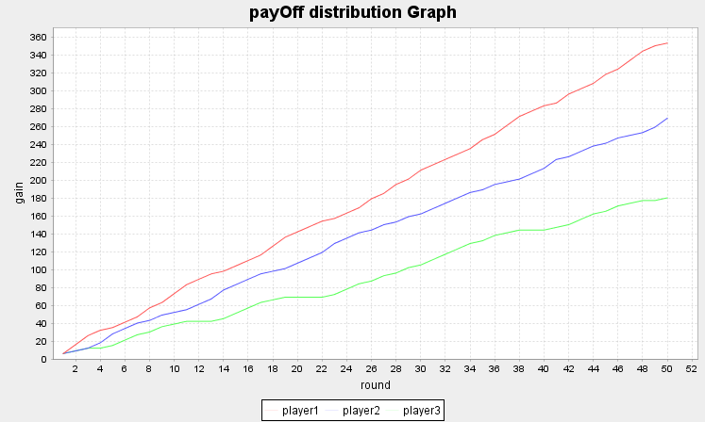

*From the graph it can be observe that, the correlation between the strategies is almost linear and you can use the graph to predict what strategy your partner will play.*

Democratic (score 199),eyefor2eye (score 212)and HigherOrderSpasty(score256)

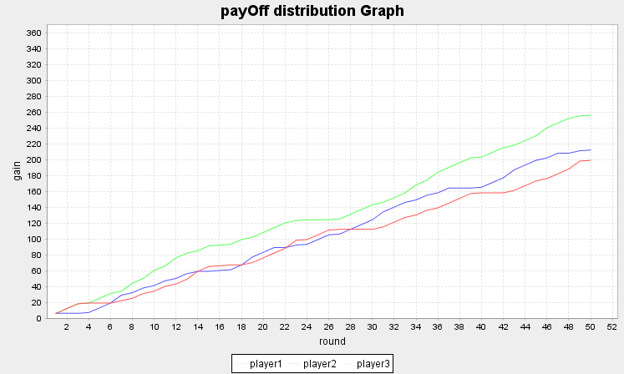

The correlation between these graphs are really close because each strategy try to predict the strategy of the opponent based of the previous history and since the simulation run for 50 times, result in better performance of the players

**Dilemma of the game**

The beauty of the Prisoner’s Dilemma, is that it remains a dilemma. There are no “right choices” or “wrong choices” per se; in most situations, neither choice is preferable to the player when compared to not playing at all.

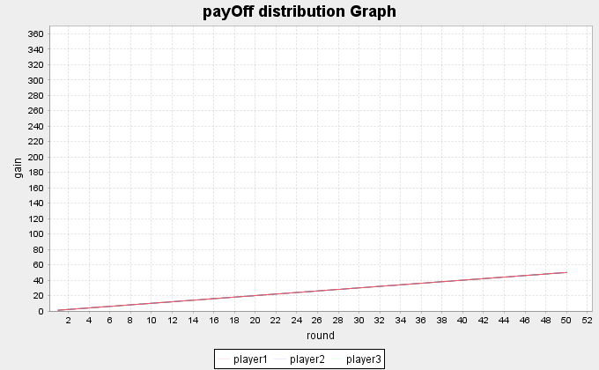

This graph represents all players using offensive strategy meaning they all defect on each round. The total score for each is 50.

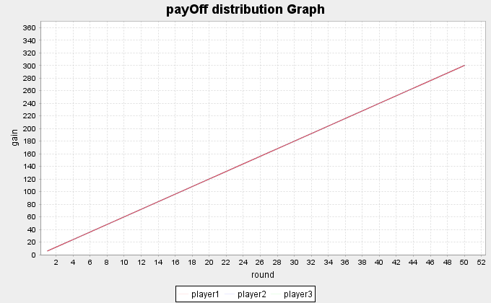

All the three players use softy strategy thus cooperate with each other, and the total score is 300 for each player which is worse than those who do not cooperate with each other.

Nevertheless, defendants must play, and they must have rules—rules that favor a proper result. No set of rules ensures that defendants will voluntarily cooperate with authorities.

The best our justice system can hope for is a set of rules that makes it more likely than not that the government will derive the benefits held by white-collar defendants.

**Payoffs**

Should be able to prosecute and investigate co-conspirators. One way to enforce a norm: punish those who do not support it. In other words, be vengeful, not only against the violators of the norm, but also against anyone who refuses to punish the defectors.”

Standards should be set enough to get most of the social benefits of regulation, (not too high or too low)

**Comparing game theory with traditional prosecution system**

|  |  |
| --- | --- |
| **Traditional Prosecution** | **Game theory** |
| **Payoffs are known after judgment** | **Payoff are known before interrogation** |
| **Very costly and time consuming** | **Cheaper and easy to implement** |
| **Witnesses confession are valuable** | **Exploitation of Pain and pleasure (nature)** |
| **Scientific methods and forensic proofs** | **Artificial intelligence with psychology** |
| **Good and clever lawyer can defend you and acquitted** | **Your faith lies in your truthfulness and that of your partner(s) in crime** |
| **Interrogation under stress and public** | **Can be done in relax condition** |
| **Cases Adjourn gives clues to next cause of action among culprits** | **No consultation among culprits** |
| **Prosecutor can manipulate sentences** |  |
| **power to decide which witnesses should be permitted to testify for the state shifted to the prosecutor,** |  |

**Conclusion**

Game theory is a study of conflict between thoughtful and potentially deceitful opponents. “Is any situation where two or more parties find themselves competing over interests they cannot easily divide among themselves? The “interests” discussed in this Note are the sentences of white-collar criminals. Game theory is useful for analyzing a situations, even those that at first glance do not resemble a game. Game theory might predict future behavior among criminal defendants

In this scenario, they are competing not only with the other defendant, but also with the prosecutor, a dually interested party, interested both in the length of the defendant’s sentence, and the depth of the defendant’s information.

*Nature has placed mankind under the governance of two sovereign masters, pain and pleasure. It is for them alone to point out what we ought to do, as well as to determine what we shall do. On the one hand the standard of right and wrong, on the other, the chain of causes and effects, are fastened to their throne. They govern us in all we do, in all we say, in all we think: every effort we can make to throw off our subjection, will serve but to demonstrate and confirm it. (****Jeremy Bentham (1748—1832)****)*

**Future work**

Our future work is to build a distributed version of this application such that it may allow players to be evaluated at the same time but different location.

Also, we want design and implement new strategies that really fit real life expectation.

**References**

* Eric Rasmusen :Introduction to Game theory
* Joel Waston : Strategy Introduction
* Enron scandal : Wikipedia